**Project Design System**

**Serverless Contact Form Using AWS Services**

Jonathan Bernard, Ashan Viville, & Avi Patel  
Monroe College  
CS670 – Cloud Computing  
Instructor: Mahmud Islam

6/11/2025

**Diagram**

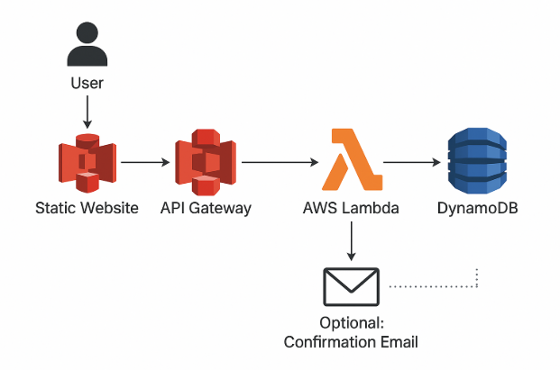

**Diagram Explanation:**

The system design diagram explains a fully serverless contact form app architecture on AWS. It starts when a user visits a static website hosted on Amazon S3 and fills out a contact us form. This data is securely passed onto the Amazon API Gateway, which is the entry point of the backend powered by trustable and scalable request receiving.

AWS Lambda processes the form submission on invocation from the API Gateway. It is responsible for validating data and business logic before actually writing data to Amazon DynamoDB, a fully managed, low-latency, and high-throughput NoSQL database. Optionally, Lambda can call Amazon Simple Email Service (SES) to send a confirmation email to the user, allowing instant feedback to the user, improving the user experience.

This architecture demonstrates key cloud computing principles such as event-driven architecture, cost-effectiveness, and serverless scalability. This architecture, forced through the use of managed services and IAM roles, which automatically provide security, availability, and operational simplicity, can be realized through two different approaches. This design reflects best practices of serverless development while also requiring mastery of the key learning objectives of a graduate-level methods of cloud computing course.